Task 5 - New Columns & New Measures
SNOWFLAKE :
- Warehouse Creation
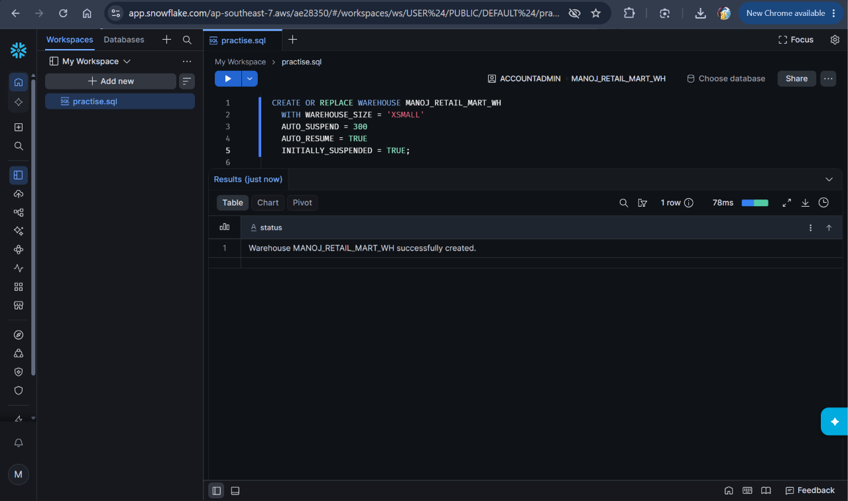

- Data base and Schema Creation
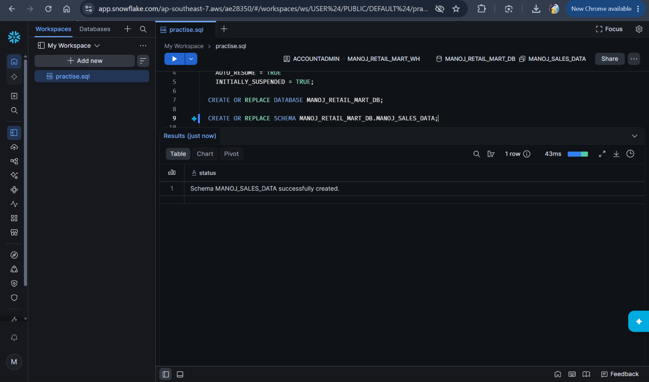

- Table Creation
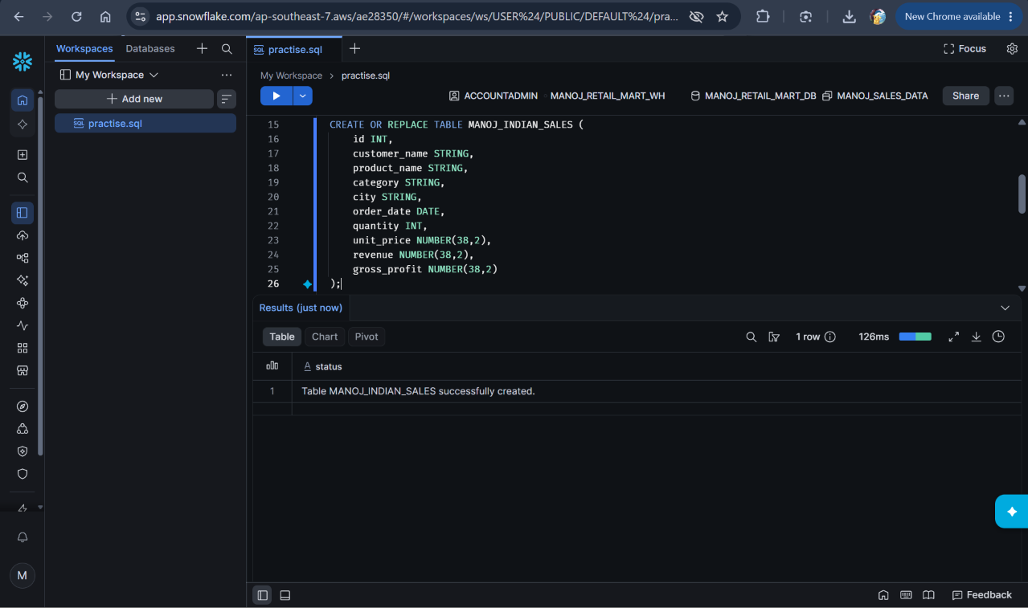

- File Format Creation
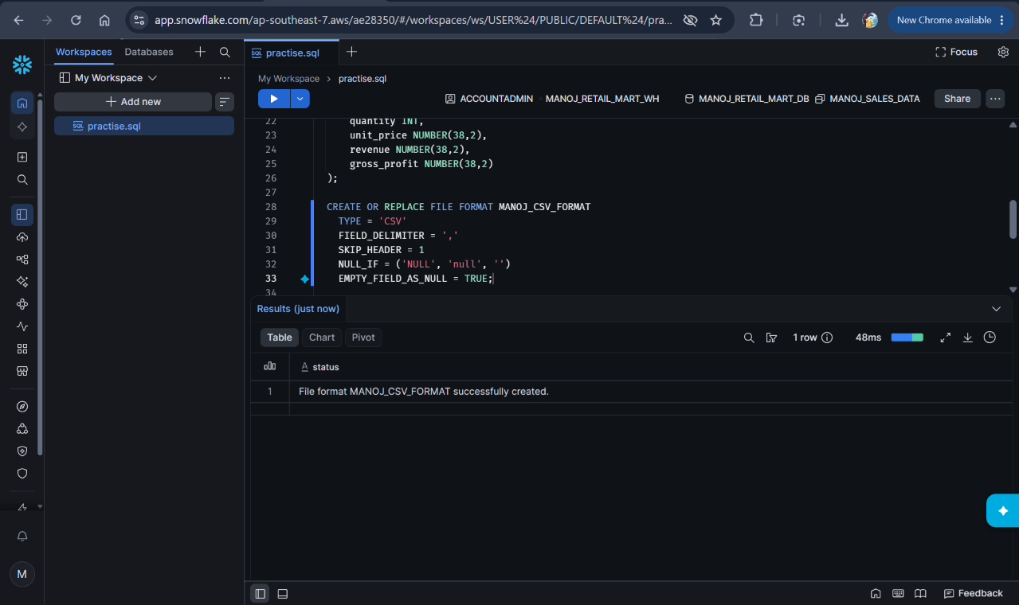

- Stage Creation
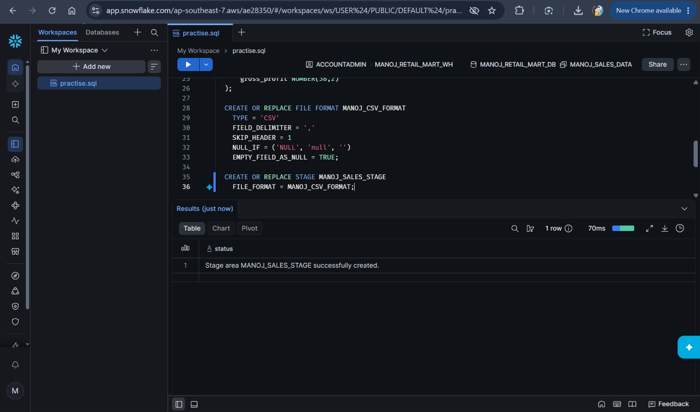

- File Upload to Stage
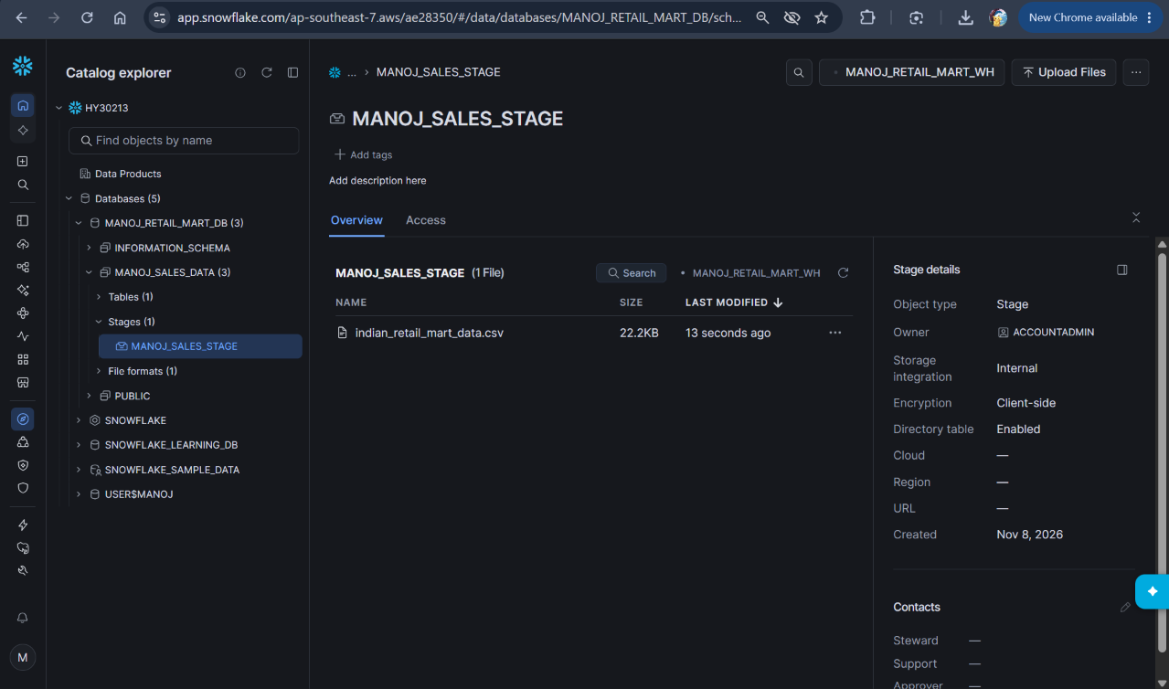

- Load Data into MANOJ_INDIAN_SALES Table
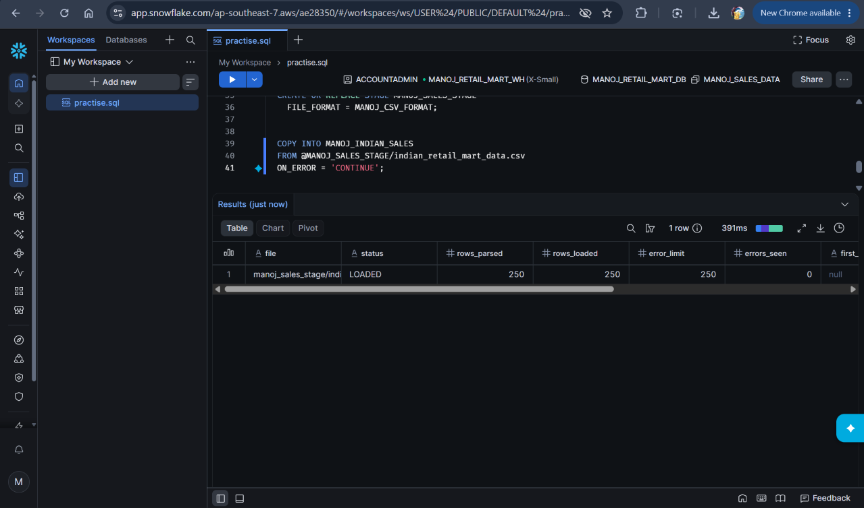

- Verfication
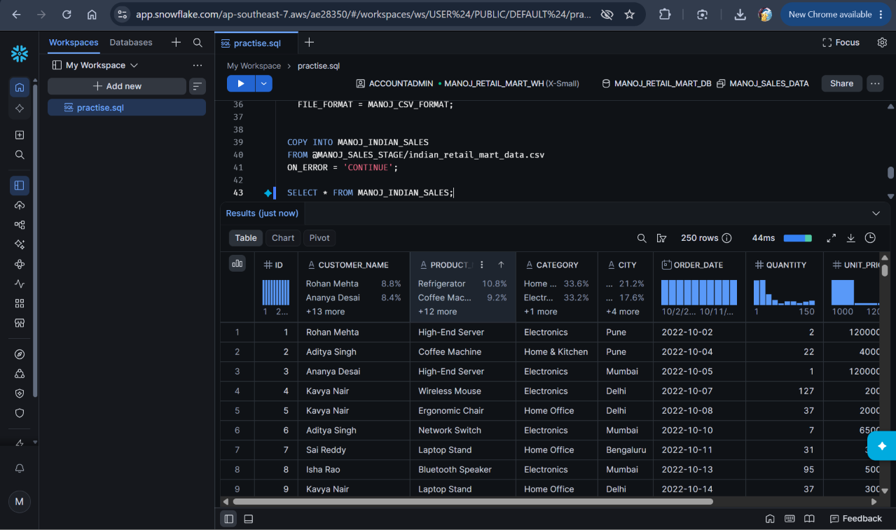

POWER BI:
- Connecting with snowflake
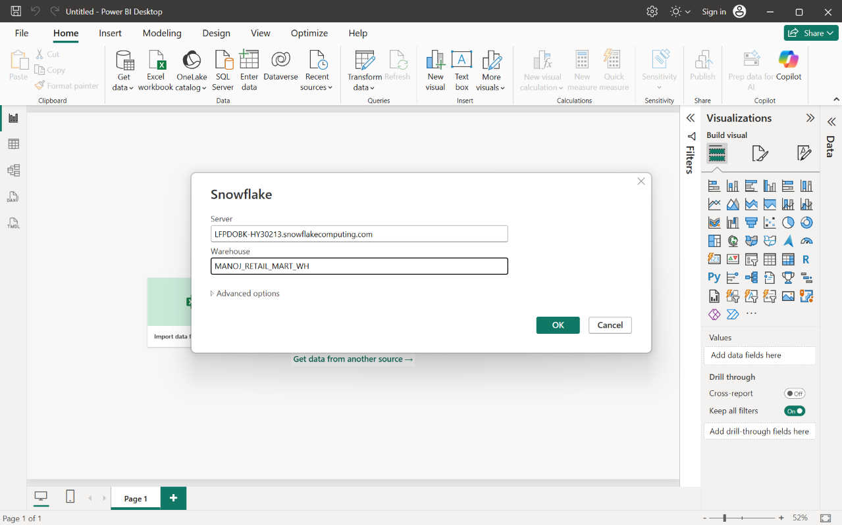

- Viewing Sales Data
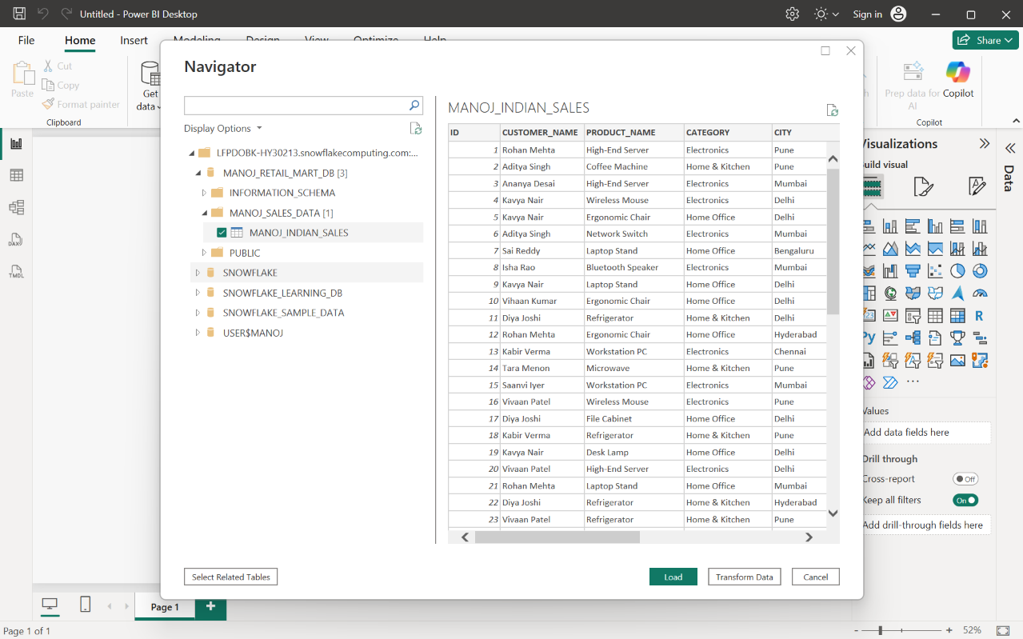

- Using Import Mode
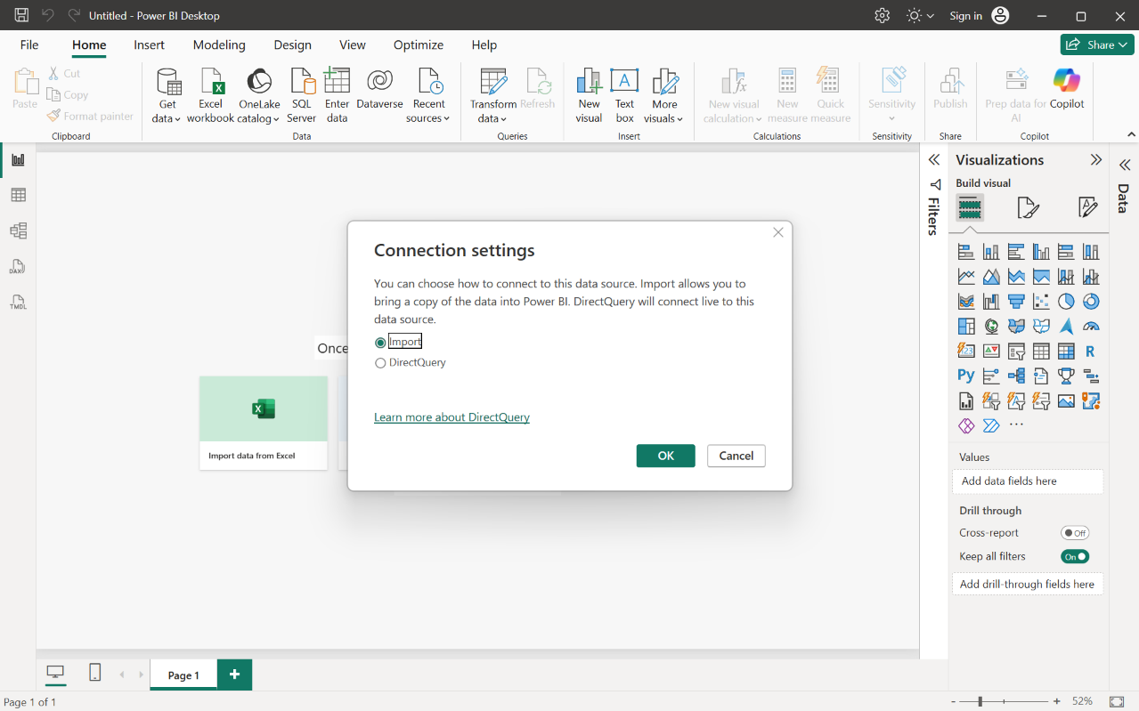

- Table View
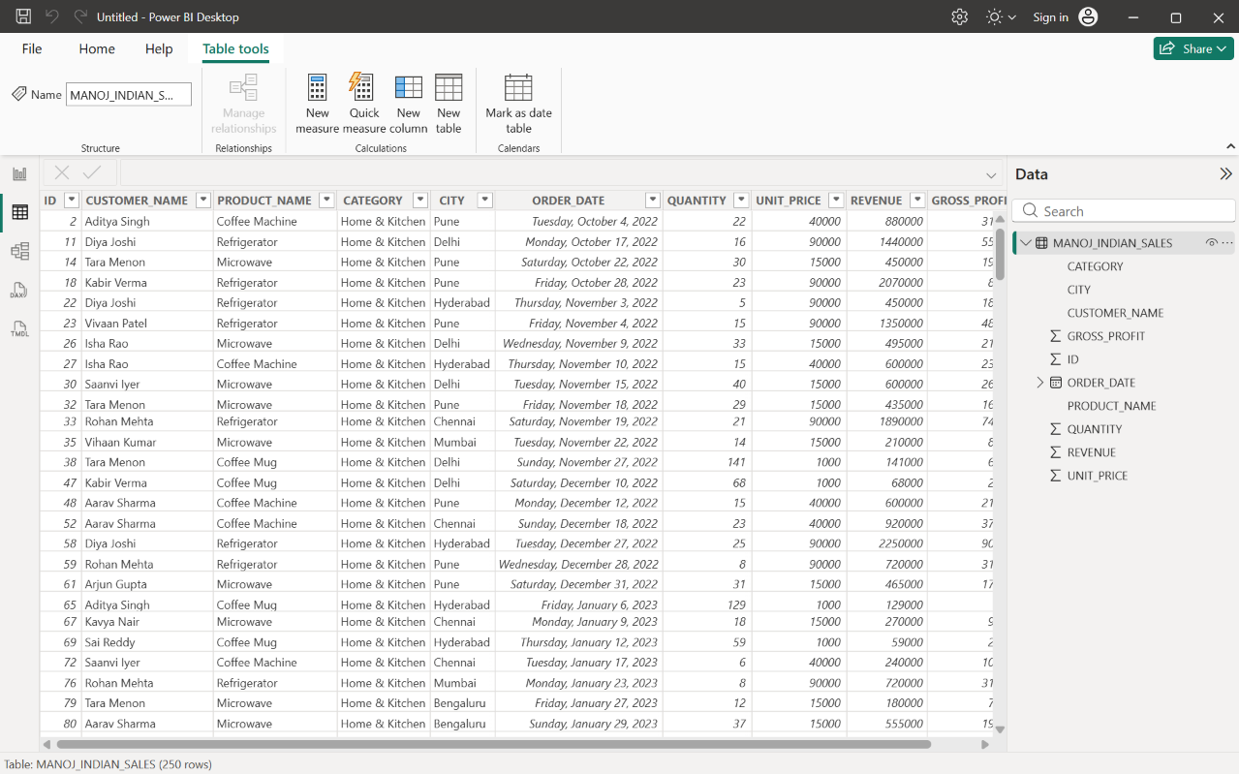

- Calculated Columns Documentation
Added 4 New Columns

The image below displays the Table View in Power BI, verifying the successful addition of four calculated columns to the MANOJ_INDIAN_SALES table. These columns were engineered to enhance the dataset with crucial time intelligence and row-level financial metrics required for the dashboard visualizations.
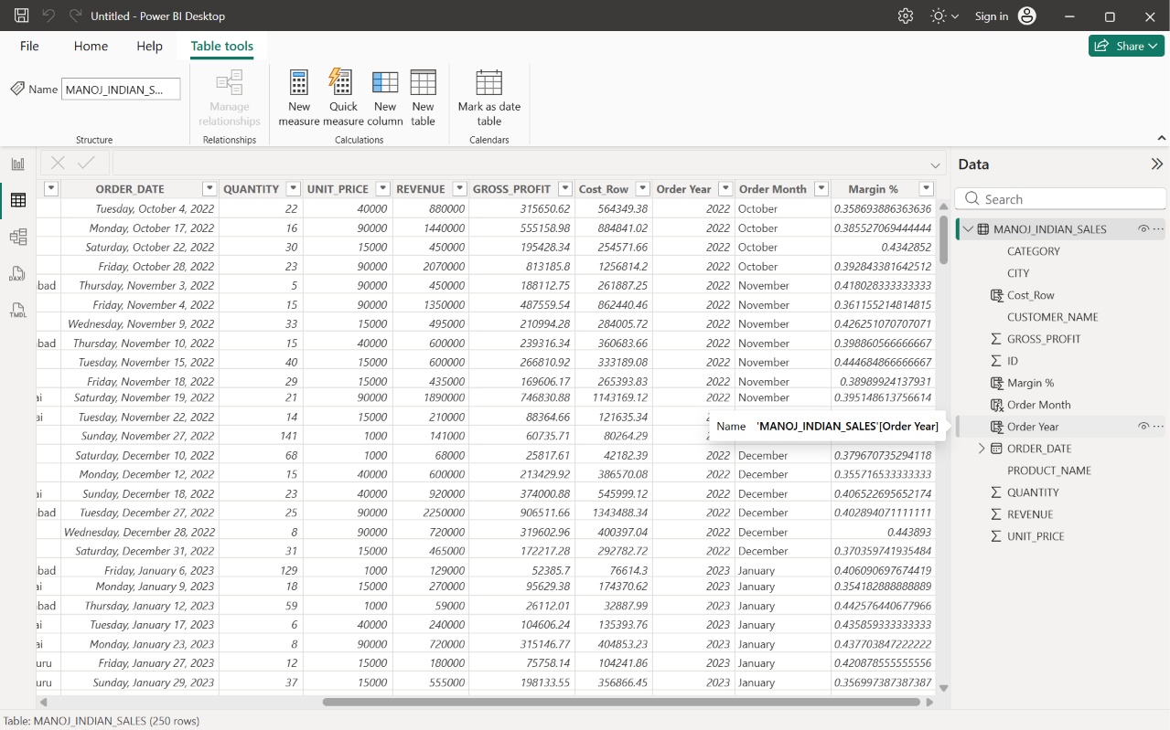
- Total Cost (Row Level)

  - DAX: Cost_Row = MANOJ_INDIAN_SALES[revenue] - MANOJ_INDIAN_SALES[gross_profit]
  - Reason: This extracts the exact Cost of Goods Sold (COGS) for each transaction. Since the raw dataset only provided revenue and profit, calculating the baseline cost is necessary for comprehensive expense tracking and supports the aggregate "Total Cost" metric on the main dashboard.

- Order Year

  - DAX: Order Year = YEAR(MANOJ_INDIAN_SALES[order_date])
  - Reason: This extracts the specific year from the raw datetime format. It is required to enable year-over-year (YoY) trend analysis and allows executives to quickly filter the entire report by annual performance.

- Order Month

  - DAX: Order Month = FORMAT(MANOJ_INDIAN_SALES[order_date], "MMMM")
  - Reason: This converts numerical dates into readable month names (e.g., "October", "November"). It acts as a critical time-intelligence dimension, ensuring that axis labels on time-series visuals (like the Sales Trend Line Chart) are intuitive and clearly highlight seasonal purchasing patterns.

- Profit Margin % (Row Level)
  - DAX: Margin % = DIVIDE(MANOJ_INDIAN_SALES[gross_profit], MANOJ_INDIAN_SALES[revenue], 0)
  - Reason: This calculates the profit ratio for every individual order. While the dashboard uses a macro-level measure for total margin, establishing this metric at the row level allows data analysts to quickly spot transactional outliers, such as specific deals that were sold at a loss or at exceptionally high markups.

- Measure Creation
Report View > Right Click on Table Name > New Measure

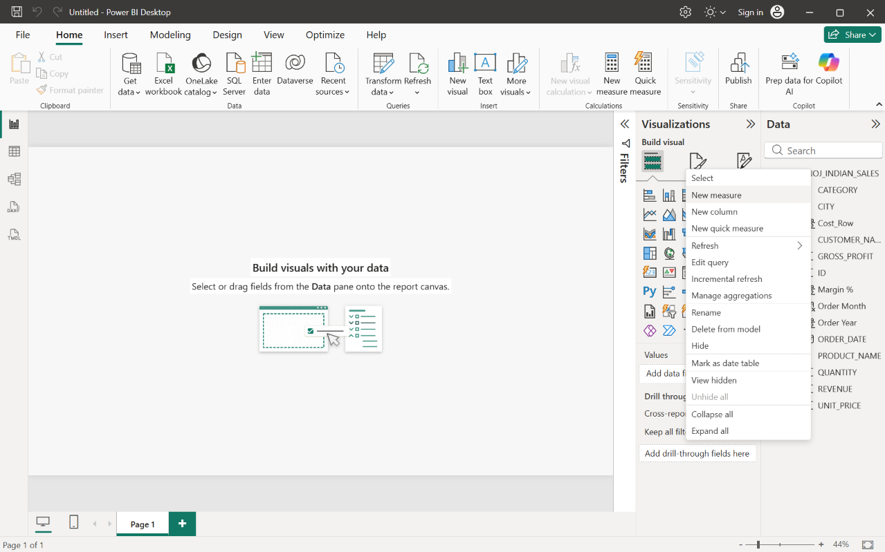

- 10 Dax Measures
The image below displays the Report View in Power BI, verifying the successful creation of ten DAX measures in the MANOJ_INDIAN_SALES table. These measures serve as the core analytical engine for the dashboard's KPI cards and visual targets.

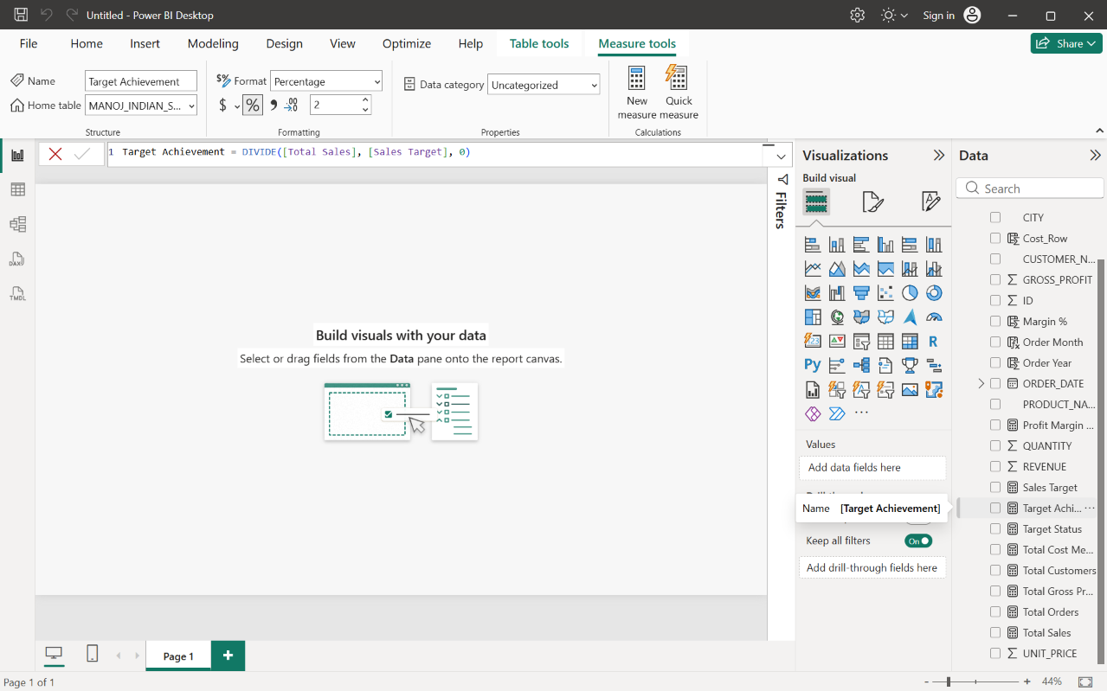

- Total Orders
  - DAX: Total Orders = DISTINCTCOUNT(MANOJ_INDIAN_SALES[id])
  - Reason: This tracks the total volume of individual transactions. It is essential for understanding the operational workload and overall sales activity independent of the monetary value.

- Total Customers
  - DAX: Total Customers = DISTINCTCOUNT(MANOJ_INDIAN_SALES[customer_name])
  - Reason: This measures the unique client base interacting with the business. It is critical for evaluating market penetration, customer acquisition, and retention rates across the dataset.

- Total Sales
  - DAX: Total Sales = SUM(MANOJ_INDIAN_SALES[revenue])
  - Reason: This calculates the primary top-line metric indicating the overall financial performance and revenue generated by the business across all categories.

- Gross Profit
  - DAX: Total Gross Profit = SUM(MANOJ_INDIAN_SALES[gross_profit])
  - Reason: This aggregates the actual earnings after subtracting the base costs. It is a vital health indicator, showing the real financial gain before operational expenses.

- Average Order Value (AOV)
  - DAX: Avg Order Value = DIVIDE([Total Sales], [Total Orders], 0)
  - Reason: This determines the average revenue brought in per transaction. Tracking AOV is a key strategy for evaluating pricing models and measuring the success of upselling efforts.

- Sales Target
  - DAX: Sales Target = 200000000
  - Reason: This establishes a static financial benchmark for the dashboard. Having a fixed target is necessary to track the sales team's progress and evaluate performance against business goals.

- Total Cost
  - DAX: Total Cost Measure = [Total Sales] - [Total Gross Profit]
  - Reason: This aggregates the total Cost of Goods Sold (COGS). It is required by management to monitor inventory spending and ensure that the cost to produce or acquire goods remains sustainable.

- Target Achievement
  - DAX: Target Achievement = DIVIDE([Total Sales], [Sales Target], 0)
  - Reason: This calculates the exact percentage of the sales goal that has been completed. It ensures that if sales are below the threshold, stakeholders can see exactly how close they are to the goal (e.g., showing 75% achieved rather than a raw number).

- Target Status
  - DAX: Target Status = IF([Target Achievement] >= 1, "Target Met", "Target Missed")
  - Reason: This provides a clear, text-based conditional indicator. It allows executives to glance at the dashboard and immediately understand if the business is on track without having to interpret the underlying percentages.

- Profit Margin
  - DAX: Profit Margin Measure = DIVIDE([Total Gross Profit], [Total Sales], 0)
  - Reason: This shows the profitability ratio of the business. It is arguably the most important KPI, indicating exactly what percentage of every Rupee earned translates directly into profit.

- Visualization & Slicers
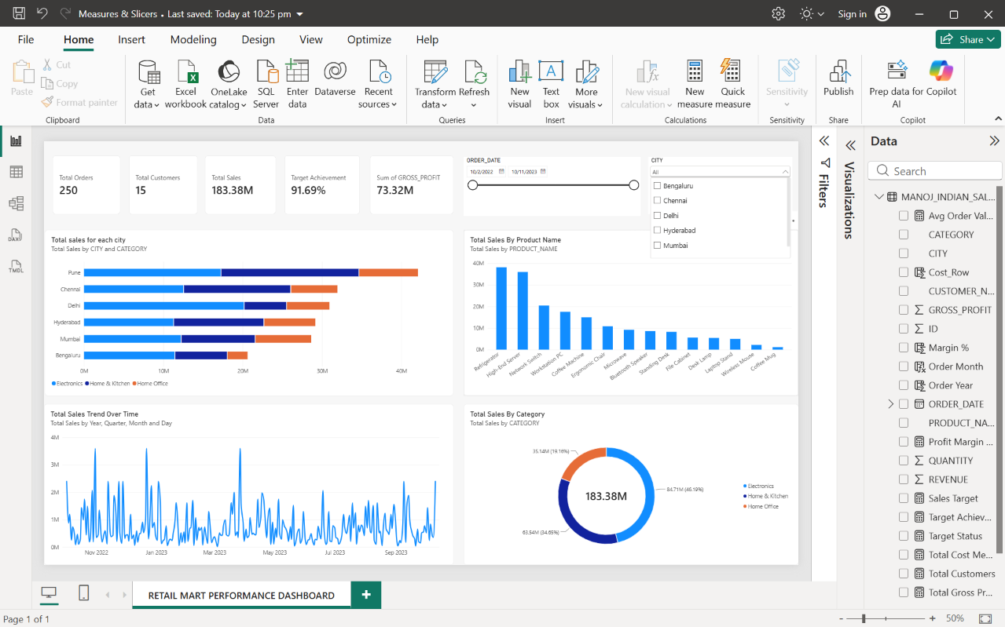

Retail Mart Performance Dashboard: Report View Documentation:
The finalized Report View provides a comprehensive, interactive overview of the Retail Mart sales data, utilizing professional styling, unified card backgrounds, and a clean grid layout.
1. Executive KPI Scorecard (Top Row)
A consolidated header of KPI cards provides immediate visibility into the core financial and operational metrics.
- Total Orders (250): Displays the aggregate volume of transactions processed using the DISTINCTCOUNT DAX measure.
- Total Customers (15): Highlights the active B2B client base, indicating a high rate of repeat purchasing.
- Total Sales (183.38M): Represents the primary top-line revenue generated across all regions and categories.
- Target Achievement (91.69%): A percentage-based measure comparing Total Sales against the predefined baseline target.
- Sum of GROSS_PROFIT (73.32M): Displays the total earnings after subtracting the Cost of Goods Sold (COGS), serving as the primary indicator of business health.

2. Interactive Slicer Configuration (Top Right)
The filtering controls have been formatted to maximize canvas space while providing full interactivity.
- ORDER_DATE (Between Slider): Configured as a horizontal slider (10/2/2022 to 10/11/2023), allowing users to seamlessly define custom reporting periods for seasonal analysis.
- CITY (Dropdown Menu): Converted from a standard vertical list to a space-saving dropdown menu. This allows users to instantly filter the entire dashboard to view performance metrics for specific geographic markets like Pune or Bengaluru.

3. Core Visualizations
The main canvas is divided into four distinct charts, each answering a specific business question.
- Total Sales for Each City (Stacked Bar Chart): Compares the overall revenue generated by each city, with the bars segmented by Solution (Category) to show the exact product mix driving regional performance.
- Total Sales By Product Name (Clustered Column Chart): Ranks individual products by revenue. It immediately identifies high-yield items (e.g., Refrigerators, High-End Servers) versus low-yield accessories.
- Total Sales Trend Over Time (Line Chart): Maps the trajectory of sales across the available date hierarchy (Year, Quarter, Month, Day), revealing purchasing spikes and seasonal patterns.
- Total Sales By Category (Donut Chart): Visualizes the proportional revenue contribution of the three main business units (Electronics, Home & Kitchen, Home Office), complete with percentage breakdowns and total aggregate sales in the center.

